What is Multiple Sclerosis (MS)?
Multiple Sclerosis (MS) is a neurodegenerative disease that affects the central nervous system. Its main effect is the demyelination(destruction of the myelin sheath) of nerve fibers, which impairs the brain's ability to seamlessly communicate with the rest of the body. This disruption leads to various motor, sensory, cerebellar, and cognitive dysfunctions.

How MS Affects Posture
Maintaining an upright, stable posture is a complex task that requires the brain to continuously integrate visual, vestibular, and somatosensory information. Because MS damages these neurological pathways, patients frequently experience notable balance and postural impairments:

- Increased Postural Sway: People with MS demonstrate substantially greater static postural sway compared to healthy individuals, which is measurable via increased sway area, velocity, acceleration, and jerk(speed/smoothness of acceleration).
- Postural sway is normal. It is tiny movements made around the center of your body to keep it standing straight. Excessive sway can be an indicator of underlying health issues(such as MS).

- Directional Instability: Specific sway metrics, such as the length and acceleration amplitude of medio-lateral sway, are significant independent predictors used to differentiate people with MS from those without the condition.
- Medio-lateral sway, also known as side-to-side sway, is used as an important predictor of MS. It can also be used to simulate MS much better.

- Task Complexity Vulnerability: The postural stability of MS patients deteriorates rapidly as the physical task becomes more complex (Even something as simple as moving from a normal, feet-apart stance to a tandem or semi-tandem stance).
- Tandem stance is when the feet are placed in a line, like a catwalk. A semi-tandem is when the feet–instead of being right next to each other–are placed next to one another with a slight stagger front or back.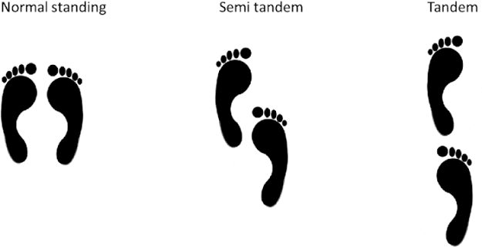

- Cognitive-Postural Interference: Individuals with MS often experience cognitive impairments alongside motor deficits. When asked to perform a cognitive task while standing, their postural sway increases significantly because their central nervous system struggles to allocate resources to both tasks simultaneously.
- If you fall over you could literally say you thought too hard.

How to Replicate MS Posture for Model Training
If you want to train your machine learning model to recognize MS-like postural instability without having MS patients directly provide data, you can simulate these sensory and cognitive deficits in healthy participants:

- Alter Sensory Input: Place a compliant foam pad on top of the Wii Balance Board. This dampens the reliable somatosensory feedback from the feet, forcing the participant to rely on other senses, mimicking the sensory deficits seen in MS. You can also have participants close their eyes to remove visual feedback.

- Introduce Cognitive Load: Because MS patients suffer from cognitive-postural interference, you can mimic this dual-task cost in healthy users. Have participants perform a challenging mental task(such as the Stroop color-word test or serial subtractions) while trying to maintain their posture on the board.

- Induce Muscle Fatigue: Fatigue severely worsens postural sway and is a hallmark symptom of MS. You can simulate this by having your healthy participants perform a fatiguing exercise (Lots of squats, or a 30 second plank) immediately prior to recording their balance data.

